Phase 1: install Ollama, choose a model
A 7B model generally needs around 8GB of RAM/VRAM.
Here are the best 3 models available on Ollama that you can compare, balancing performance with the ability to run them on typical hardware:
The Best 3 Models for 8GB RAM Laptop

Model Name | Key Strengths for this Project | Considerations
Llama 3 (e.g., llama3:8b) | Strong general-purpose reasoning and instruction following; a community favorite. Good balance of capability and resource needs. | Might require more specific prompting to act as an "expert" agent initially, but highly capable with refinement.
Mistral / Mixtral (e.g., mistral:7b or mixtral:8x7b) | Known for efficiency, speed, and strong performance in complex tasks. mixtral (a Mixture-of-Experts model) offers higher quality reasoning but requires more RAM. | mistral:7b is very efficient and runs well on CPU. mixtral:8x7b needs a more powerful machine (around 25-30GB RAM) to run effectively.
Qwen 2.5 (e.g., qwen2.5:7b or qwen2.5:32b) | Excels at complex reasoning, coding/tool use (which is useful for managing data and generating structured output), and multilingual support. | The 7B version is a good starting point. The 32B version offers superior performance but has higher hardware requirements.

Why these models?
- Reasoning & Instruction Following: Your agent needs to understand complex, conditional logic (e.g., "if usage is X and current plan is Y, suggest plan Z to save cost"). These models are noted for strong reasoning benchmarks.
- Context Length: Telecom plans can be complex. These models generally offer sufficient context length to hold all the necessary pricing, usage, and option details in memory during an interaction.
- Availability on Ollama: All of these models are readily available on the Ollama library and are well-supported for local execution.

How to Compare Them
You can compare them based on the following quality parameters over each iteration of improvement:
- Accuracy of recommendations: Does the suggested plan actually improve cost based on the provided data?
- Reasoning clarity: Is the explanation for the recommendation easy for a human (or your grading script) to understand?
- Response time (latency): How quickly does the model provide an answer on your specific hardware? (A smaller model might be faster, even if a large one is more "intelligent").
- Resource usage: How much RAM/VRAM does each model consume?

By testing the same data and prompts across these three models, you can objectively determine which one is most suitable for your prototype.

How to install them in Ollama?

Model | Command
Llama 3 (8B version) | ollama pull llama3:8b
Mistral (7B version) | ollama pull mistral:7b
Qwen 2.5 (7B version) | ollama pull qwen2.5:7b

Phase 2: Develop, Test, and Document (The Iterative Process)
We will use Python >= 3.12 and the ollama library.
1. Setup Your Project Structure
Organize your GitHub repository with these files and directories:
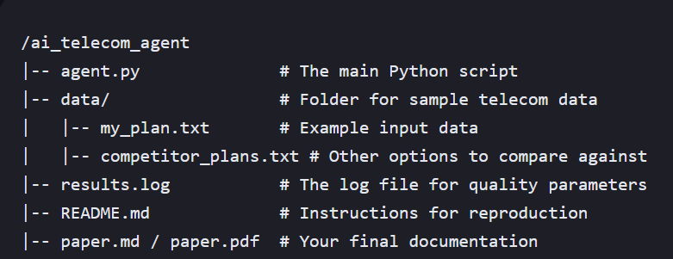

2. Develop the Core Logic (agent.py)
The "training" phase for an LLM project mostly refers to prompt engineering and data refinement, as you are using a pre-trained base model.
Your script will need to:
- Load the data from the data/ directory.
- Define a robust system prompt that tells the model how to act.
- Define the user prompt that feeds in the data and the specific query (e.g., "how to improve cost iteratively").
Key Python Implementation Steps:
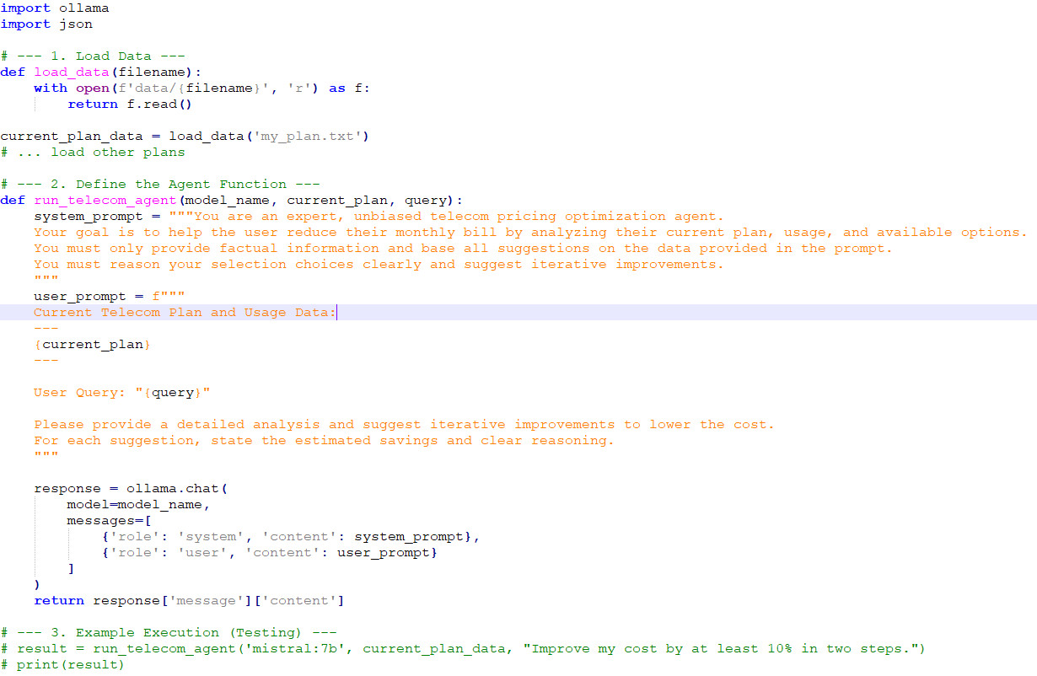

CODE:
3. Maintain a Log of Key Quality Parameters (results.log)
You must track how well your agent performs across different models and prompt iterations. This is crucial for the "training/testing" requirement.
Create a function to log results to results.log. You should manually or programmatically rate the results.
Log Parameters to Track:
- Model Used: mistral:7b, llama3:8b, etc.
- Prompt Version: V1, V2 (if you refine your prompts).
- Recommendation Accuracy: (Rate 1-5) Did the suggestion actually save money based on data provided?
- Reasoning Clarity: (Rate 1-5) Was the explanation easy to understand?
- Response Time: How long the generation took.

Example results.log entry (you can append to this file via Python):
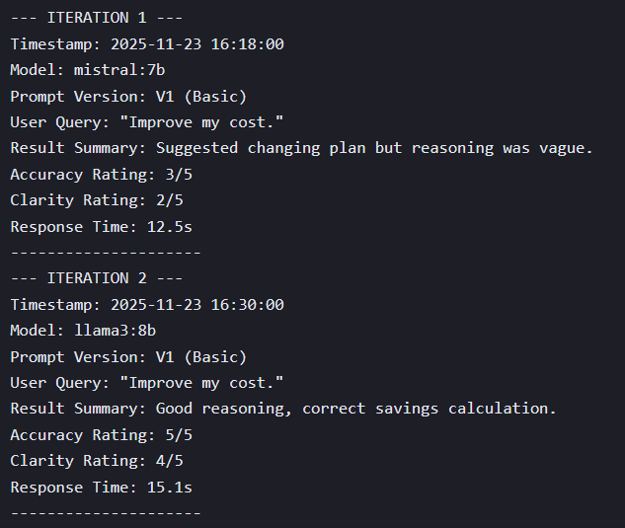

4. Add Reasoning and Answer Aggregation
The model provides reasoning within its response (e.g., "By switching to Plan B, you save $5/month because...").
Your logging and paper will aggregate these answers and evaluate the model's performance on providing quality reasoning.
In your agent.py file, you can add simple logic to test multiple models sequentially and aggregate the outputs for comparison:
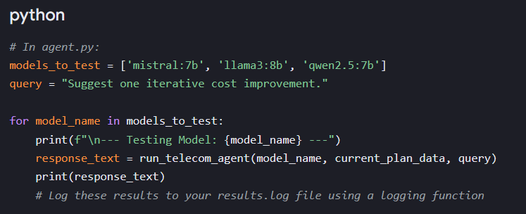
# In agent.py:
models_to_test = ['mistral:7b', 'llama3:8b', 'qwen2.5:7b']
query = "Suggest one iterative cost improvement."

for model_name in models_to_test:
print(f"\n--- Testing Model: {model_name} ---")
response_text = run_telecom_agent(model_name, current_plan_data, query)
print(response_text)
# Log these results to your results.log file using a logging function

